TITLE OF THE PAPER (Arial - 14 pt Bold)
(Arial 10 pt)
First A. Author¹, Second B. Author², Third C. Author³, … ( Arial 12 )
¹ Institution, Address, City, COUNTRY, e-mail (Arial 10 pt)
² Institution, Address, City, COUNTRY, e-mail (Arial 10 pt)
(Arial 10 pt)
(Arial 10 pt)
Abstract (Arial 10 pt Bold): The length of abstract 10-line max., type of font Arial, 9 points normal, left and right centered.
Keywords (Arial 10 pt Bold): keywords 1, keywords 2, keywords 3, keywords 4, keywords 5 (max. 5 Arial 10 pt)
(Arial 10 pt)
(Arial 10 pt)
(Arial 10 pt)
1. INTRODUCTION (Title of chapter Arial 12 pt Bold)
(Arial 10 pt)
These are the guidelines for writing the paper for the 10th International Professional and Scientific Conference Occupational Safety and Health. They are written in the format that is being described. Please follow these instructions.
(Arial 10 pt)
(Arial 10 pt)
2. TECHNICAL REQUIREMENTS
(Arial 10 pt)
The paper should be written in English (Arial-10 pt normal).
Text editor: Microsoft Word.
Paper length is limited to 6 (six) pages.

2.1. Format

Use A4 (21x29,7 cm) page format with margins (mm): 25 top, bottom, left and right.

2. 2. Tables

Each table is numbered. Table caption is in Arial 9 pt, placed above the table, centered and has the following style.

Table 1: Table caption
Column 1 | Column 1 | Column 1
Row 1 | Row 1 | Row 1
Row 2 | Row 2 | Row 2
Row 3 | Row 3 | Row 3

2.3. Figures

Figures should be numbered. Please do not insert text boxes over the figures. Figure caption is in Arial 10 pt, placed below the figure, centered and has the following style:
(Arial 10 pt)
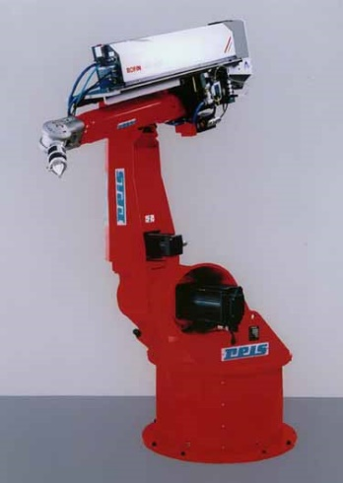
Figure 1: Figure caption

2.4. Equations

Equations are left justified 5 mm from margin with equation number at the right margin in font Arial 10 pt Italic.
(1)

3. CONCLUSION

Paper delivered after the deadline or in incorrect form shall not be published in the Book of Proceedings.

Table 1: Styles in use in the preparation of this document

Style name | Typeface | Size | Alignment | Line spacing
Paper title | Arial Bold | 14 pt | Centred | Single
Author | Arial Regular | 12 pt | Centred | Single
Address | Arial Regular | 10 pt | Justified | Single
Abstract text | Arial Italic | 10 pt | Justified | Single
Figure caption | Arial Regular | 9 pt | Left | Single
Heading 1 | Arial Bold | 12 pt | Justified | Single
Heading 2 | Arial Bold | 10 pt | Justified | Single
Normal text | Arial Regular | 10 pt | Justified | Single
References | Arial Regular | 10 pt | Justified | Single
Table caption | Arial Regular | 9 pt | Justified | Single

REFERENCES

References should be indicated in the text using consecutive numbers in square brackets, e. g.[1]. In the bibliography (by ISO 690) they should be cited including the title of the paper:

- Surname, N.; Surname, N.: Name of Book (in Italics), Publisher, ISBN, Place of Publication, (YYYY)
- Surname, N. & Surname, N.: Name of paper or Chapter, In Name of Book (in Italics), Publisher, ISBN, Place of Publication, (YYYY), pp. xxx-yyy
- Surname, N.; Surname, N. & Surname, N.: Title of conference paper, Proceedings of xxx xxx, Surname, N. (Ed.), pp. xxx-yyy, ISBN, conference location, Month and Year, Publisher, City, (YYYY)
- Surname, N.: Name of paper, Name of Journal (in Italics), Vol. (YYYY) No., pp. xxx-yyy, ISSN
- Surname, N.; Surname N. & Surname N.: Name of Paper, Available from http://www.exact-address-of-site Accessed: YYYY-MM-DD.

Please save your paper as OSH_2026_Paper_Surname.docx written according to the provided guidelines and submit it using the online upload form no later than May 15, 2026.

4. Corresponding Address

Please send your Paper to:

